CT70A3000 Software Maintenance
Project Tasks
Spring 2026

GitHub: https://github.com/OskariLeh/Software-Maintanance-Course/
Demo link: https://www.youtube.com/watch?v=FC896zGv4XI
Oskari Lehtonen
oskari.m.lehtonen@student.lut.fi
0604182
Table of Contents
T1. Code Comprehension 3
T2. Refactoring 3
T3. Adding New Features 3
T4. Testing and Test Coverage 4
Appendices 5

This document contains the high level description of the system under T1. Code comprehension. The class diagram in appendices and a brief description of each tasks work done. A more detailed explanation can be found in the YouTube video provided.

T1. Code Comprehension
- Task: Analyze the project and create comprehensive documentation.
  - Generate a class diagram, sequence diagram, or dependency graph for the project.
  - Write a high-level description of the system's architecture and its main components.
Appendix 1 shows the class diagram of the system. We have an inventory management system comprised of 7 classes. The main class IMS handles the main menu and dashboard of the system and can call each one of the other classes except for billClass. Each one of the other classes, however, can exist without the main class and there can be any number of them. Then we have the productClass that is composed of the supplier and category class. Each product has to have one category and one supplier.
On a high level the system functions by having different interfaces. All classes by themselves function as independent interfaces but the main use is to use the system by the IMS class which is the dashboard and the billClass which can handle sales. The system uses PIL and TKinter to generate a user interface for the sqlite database that is stored locally in the project directory. The interface functions as a way to show the contents and edit the sql database.

T2. Refactoring
- Task: Improve the code quality through refactoring. Simplify complex methods, eliminate code duplication, or improve naming conventions.
For this part I edited some variable names that I thought were typos or spelled wrong. I also fixed the error in the categoryClass to fix image reading and then finally fixed the use of the depradacted function mktemp and replaced it with the recommended mkstemp function.

T3. Adding New Features
- Task: Extend the functionality of the project.
  - Implement one new feature requested by hypothetical stakeholders.
  - Modify existing components to support additional requirements of the feature.
As a new feature I added the ability to add a barcode to a product and search by the barcode. I edited the create_db.py file accordingly to create the new column in the db and edited each of the productClass methods to work with the new barcode. No special handling for a barcode scanner is needed as they function just as a normal keyboard from the perspective of the program.

T4. Testing and Test Coverage
- Task: Analyze and improve test coverage. Write unit tests (at least 3), integration tests (for 2 scenarios), and regression tests using an acceptable framework.
I only added three unit tests using the pytest library for the classes category, employee and supplier. These tests write to the database using the functions of the classes. Reads the database using the sqlite3 library and assert that a new row was added, then deletes the row using the classes functions and reads the database again to verify that the deletion worked.

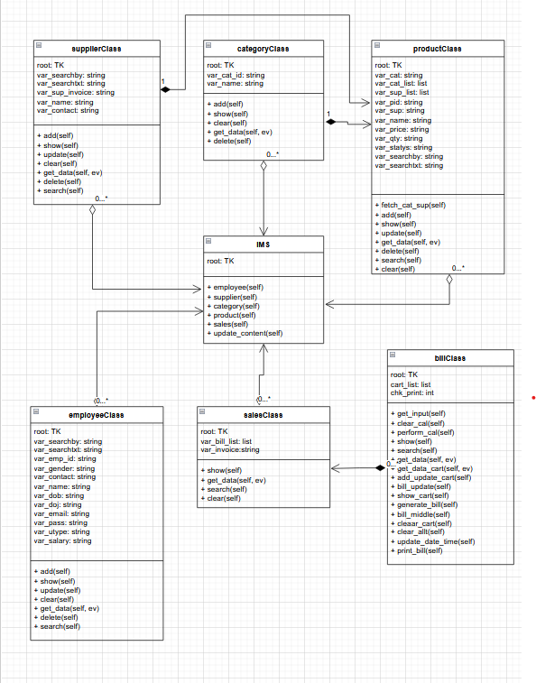
Appendices

Appendix 1. Class Diagram

